Tragedy and Congregations Team

Session 1 Trauma and the Individual Revd Hilary Ison

Confidentiality - to keep this time and space as safe as possible for learning, I’d like us to agree the following:

- This is a kind, listening space
- We speak for ourselves, and not on behalf of others
- What is said in the breakout Zoom room stays there. Afterwards we can share our own learning, not the stories of others.
- We will take responsibility for what we say: if you feel uncomfortable to share something personal, don’t do it.

‘The Body Keeps the Score’ (Bessel Van der Kolk 2014)
A foundational book in the field of trauma research - learning to recognise the ‘unspoken voice of the body’ (Peter Levine 2010:10-11)

The Felt Sense
We first know we are facing threat or danger by feeling it in our bodies somewhere – often the gut, the chest, the tensing of muscles, raised heart beat, feeling prickly, shivery, hot or cold. This is what we call the Felt Sense. This information from our bodies is conveyed by the vagal nerve, a super highway from the gut, the enteric brain, all the way up following the spine to our tri-partite brain, relaying information about the state of our organs and digestive system.
About 80% of the fibres in the vagal nerve run up from the gut to the brain, and only 20% run down from the brain to the gut. So the vast majority of of information that our brain is receiving on how we are and what we are feeling, which subliminally influences our decisions and actions, is coming from our felt sense, our ‘gut brain’.
One of vagus nerve’s primary functions is to control the body’s parasympathetic nervous system (PNS) which regulates the body’s relaxation mechanism. When the body is exposed to stress, it initiates a fight/flight response where the body’s sympathetic nervous system (SNS) increases the heart rate and blood pressure to deal with the stressful situation. The SNS speeds us up ready for action, the PNS slows us down, restoring us to ‘rest and digest’.

Trauma and the brain
Key points:
- Trauma is not in the event, but in the brain-body of the person. It’s a whole body response.
- Traumatic responses are entirely normal and we cannot stop them from happening. They are the way that our brains help us to survive threatening or dangerous events.
- Not everyone is traumatised by the same event; and for those who are traumatised, they may not have the same kinds of trauma responses.

The Tri- partite brain
The brain in the palm of the hand model – Dan Siegel
Introduction to the three-part brain and hand model: Dr. Russ Harris
https://www.youtube.com/watch?v=5CpRY9-MIHA
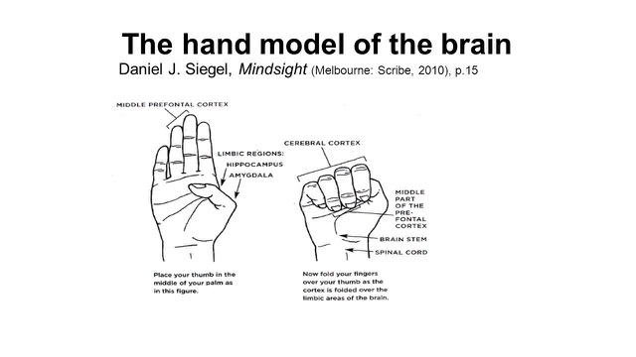

What happens in the brain in trauma?
When our amygdala (the early warning system in the limbic system/emotional brain) detects the possibility of a threat, the alarm bell goes off and things happen quickly, instinctually:

- the brain is flooded with stress hormones (cortisol, adrenalin);
- which cause the fight/flight/freeze/flop & drop responses;
- the mammalian and reptilian brains take over so that we can react quickly without thinking – we flip our lids and lose connection with our thinking brains temporarily;
- our bodies respond in a way that we cannot immediately control – instinctual reaction.

A traumatising event:
- overwhelms our normal capacity to cope
- cuts us off from our resources (because our lids are flipped)
- breaks connections: from our sense of self and safety; from others
- shatters our assumptions about the way the world should work – evoking a crisis of meaning
- renders us powerless – loss of control, living with uncertainty and not knowing

Trauma is not in the event itself, but in how it lands in our lives.

The same event or collective experience will have a different impact on individuals depending on:
- reverberations with previous traumatic experience
- resources available – personal support, good self care
- capacity for self-regulation/resilience
- personal/family/work context

Is this situation of the pandemic a trauma?

It has the potential to be in its impact:
It is not a one-off shock event as in a fire, earthquake or flood, or terrorist attack, but it is a huge body shock to the system globally, locally and personally. The trauma or crisis that keeps giving!
We have a prolonged situation of uncertainty and anxiety that is exhausting and overwhelming in its demands already and we don’t know how it’s going to play out.
Many losses have occurred already – and more to come.

Working with the Felt Sense

- Sense: notice and accept sensations in the body
- Name: name what you are feeling
- Ask: what do I need?
- Breathe

Working with Trauma

- accompaniment
- acknowledgement
- normalisation
- connecting to resource
- hope

Self-care

Put your own oxygen mask on before you seek to help others.

“Self-care is never a selfish act – it is simply good stewardship of the only gift I have, the gift I was put on earth to offer others. Anytime we can listen to true self and give the care it requires, we do it not only for ourselves, but for the many others whose lives we touch.”
Parker Palmer, Let your life speak: Listening for the voice of vocation (2000)

Self-care requires self-awareness, self-acceptance, self-compassion and self-regulation. Self-regulation is the bedrock of resilience.

The Basics:
- Focus on adequate nutrition, rest, exercise and some kind of social contact.
- Gently accept, day by day, hour by hour, what is happening in your body and brain.
- Be present and kind. Accept unpredictable feelings. Lower the goal posts of achievement; to survive is an achievement in times like these. We need to replenish 3x as much as we think we do (Revd Dr. Harriet Harris, Univ. of Edinburgh). See Tips for maintaining well-being and building resilience (Salvation Army, separate handout).

Resources Exercise: On a blank piece of paper, draw a figure to represent you.

Now add to the diagram
- the things that keep you connected to yourself, others and God;
- the things that give you resilience and strength;
- the things that keep you healthy in mind and body.

List caring relationships that sustain you – the wisdom is that six is a good number of those.

Name what most helped you stay connected and balanced during the time of lockdown.

Canary in a coalmine: How will you know (what are the clues) that you are not 100% OK?

Once you have completed the exercise, share it with someone you are close to so that they can support you and remind you to draw on your resources.

Resilience:
Rock - resolve
Tree - relationship
Sand-dune – reframing

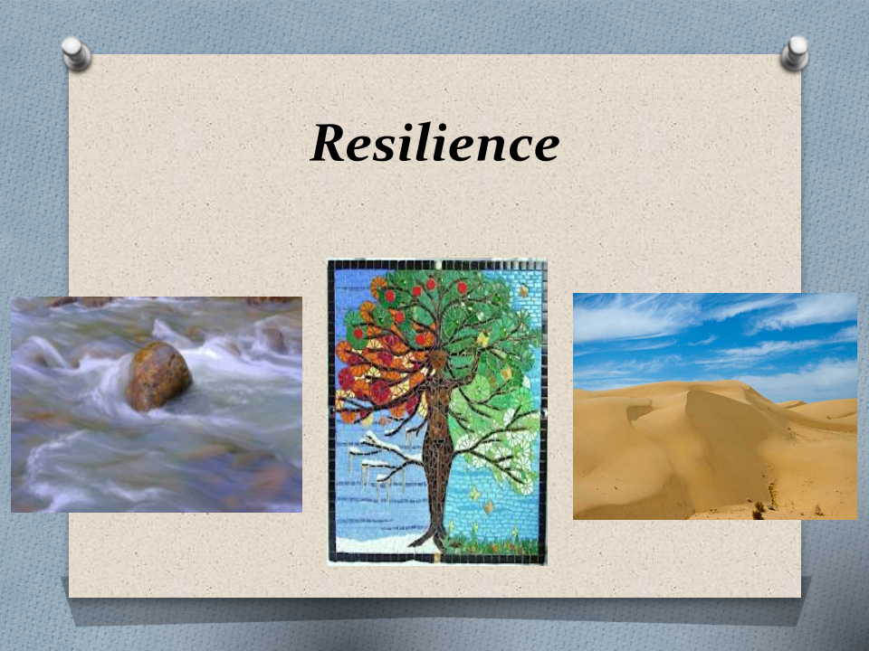

Further resources
Justine Allain-Chapman (2012) Resilient Pastors: The Role of Adversity in Healing and Growth (London: SPCK).
Laurie Kraus, David Holyan and Bruce Wismer, Recovering from Un-natural Disasters: A Guide for Pastors and Congregations after Violence and Trauma (Louisville, KY: Westminster John Knox Press, 2017.
Peter Levine (2010) In an Unspoken Voice: How the Body Releases Trauma and Restores Goodness (North Atlantic Books, Berkeley, California)
Sarah Peyton (2017) Your Resonant Self (New York, W.W. Norton & Co Inc)
Shelley Rambo, 2010 Spirit and Trauma: A Theology of Remaining, (Louisville, Kentucky John Knox Press)
John Swinton, Raging with Compassion: Pastoral Responses to the Problem of Evil (Grand Rapids, MI and Cambridge UK: William B. Eerdmans Publishing Company, 2007).
Bessel van der Kolk, The Body Keeps the Score: Mind, Brain and Body in the Transformation of Trauma (London: Random House, 2014).
Megan Warner, Christopher Southgate, Carla A. Grosch-Miller and Hilary Ison (editors), Tragedies and Christian Congregations: The Practical Theology of Trauma (London and New York: Routledge, 2019).
Note: Copies of Tragedies and Christian Congregations are available from Chris Southgate for £30 (which includes postage and packaging). Order at C.C.B.Southgate@exeter.ac.uk.
Article by Dan Siegel on the Hand Model of the brain
https://www.psychalive.org/minding-the-brain-by-daniel-siegel-m-d-2/

Hand Model of the Brain Image
https://i.pinimg.com/originals/e3/a3/b4/e3a3b41deb41eccbb55530a8e12210c9.jpg

Youtube clip on Trauma and the Autonomic Nervous System
https://youtu.be/ZdIQRxwT1I0

