Trauma-informed ministry for these times HANDOUT

Session 2: Collective trauma Revd Dr Carla A. Grosch-Miller
A group or community is traumatised when either significant individuals are traumatised or when the group’s way of relating and understanding of the world are damaged in a life-threatening way. A group also may be traumatised by the response of those responsible (e.g., the government) when it is inadequate and harms individuals or the group.
Elements of CT:
- Feelings of powerlessness and helplessness
- Acute disruption of daily existence
- Extreme discomfort
- Shattering of assumptions
The same event will have a different impact on individuals depending on:
- state of nervous system (unique life and genetic history)
- reverberations with previous traumatic experience
- resources available
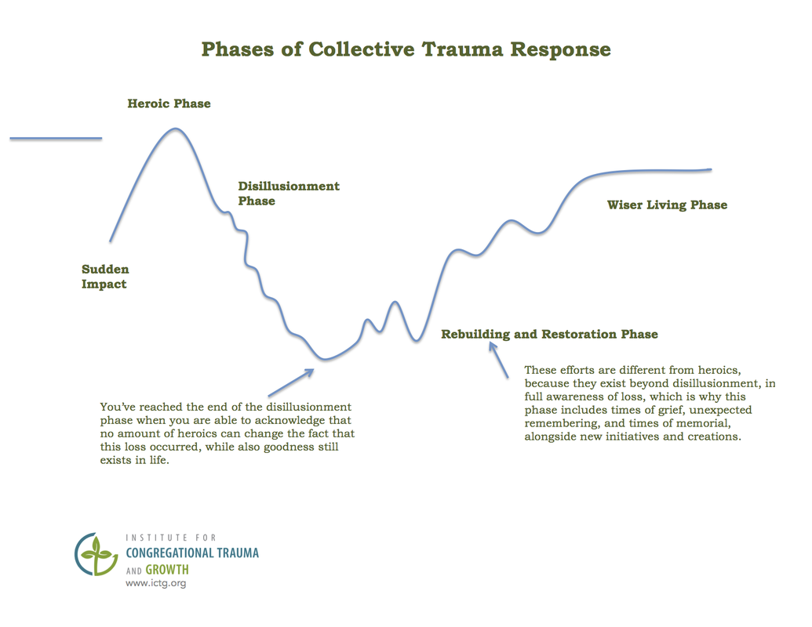
- the meaning of the event

Journey of recovery: 2-5 years or more for a single event
The British Academy - The Covid Decade: Understanding the long-term societal impacts
This chart is heuristic – to start a conversation – not prescriptive. Each traumatising event is unique to itself. For more information on the chart, see https://www.ictg.org/phases-of-disaster-response.html
Heroic:

Disillusionment:

Rebuilding and restoration:

Wiser living:

Leadership, care and comfort in these times
Where we are now – disillusionment, exhaustion, turning towards recovery
Disillusionment Phase characteristics: exhaustion, low energy, great variability and unpredictability of mood/emotions; depression; fragmentation; conflict

What’s happening:
- Rest and recovery after the shock of the pandemic
- A settling into the facts of what happened/is happening and its impacts
  - Naming and grieving losses
- Survival and adaptation
  - Sparks of new possibilities and initiatives
- Looking for ground firm enough to stand on; holding opposite ideas in our heads
- Cultivating resilience and coping with chronic stress/risk of burnout
  - Increase inputs (exercise, relaxation, connection, support) and/or
  - Reduce stressors
- A turn towards hope
- Revelation of other disturbing realities (e.g., 400 yr old pandemic of racism)
- Triggering of vulnerabilities (underlying anxiety disorders; racial discrimination; LGBT – HIV/AIDS; domestic violence -so more safeguarding issues)

You can’t force the move from disillusionment to rebuilding and restoration.
Enough people need to feel safe enough and to have made peace with the reality that
the pandemic is what it is.

Rebuilding and restoration/Reimagination: shift to general positive direction with more energy and ability to engage new initiatives; still grieving losses; triggers and anniversaries (two steps forward, three steps back).

Tasks:
- Enabling agency (countering the powerlessness of traumatic experience; the survivor is the expert)
- Enabling collective responses appropriate to local context/conditions
  - Collective trauma recovery requires collective responses.
- Resourcing the organic reframing of what happened to integrate the fact of the pandemic into the story of our life together and in God.
- Reimagining the church:
  - Focus on being real and resourcing discernment of call and purpose
  - Acknowledging vulnerability (not knowing)
  - Managing anxiety

Walter Brueggemann (Reality, Grief, Hope: Three urgent prophetic tasks, 2014):
Three prophetic tasks in a cataclysm: face reality, grieve the losses, nurture hope (God will not give up on us). Courage, Compassion and Creativity (MLK, Jr.)

Congregational challenges
- The power of fear and anxiety - decreased capacity; stuckness
- What is safety? (physical; emotional; social)
- Cultural barriers to grief or ‘negativity’ (e.g., stiff upper lip)
- The desire to return to normal and to avoid the discomfort of more challenge

Helpful leadership qualities and strategies to abet movement through the phases and towards emergence
Presence: The power of calm
- Self-care: connecting to one’s resources; self-awareness, -acceptance, -compassion and -regulation
- Lean in towards difficulties, being Calm, Curious and Connected
- Capacity to hold negative emotions without reactivity

Three C’s of pastoral strategies in aftermath of trauma –
Calm, Communication, Care

Accompaniment with resonant care: warmth plus precision
- The survivor is the expert
- The power of naming and normalisation
- Connect person to their natural support networks
- Keeping your own fix-it/over-functionning energy in check

Affirm survival and adaptation. Celebrate the good.
Enabling maturity – acceptance of human vulnerability and variability; self-responsibility. Differences are normal. We slow down, breathe and listen to one another to move forward together.

Connecting people to each other and to their personal and faith resources

The Bible as survival literature: robust, resilient, providing a language of suffering.

The resource of lamentation
The common elements of a psalm of lament are these: See, e.g., Psalm 13
- Address to God
- Complaint, including blaming God for what has happened or for doing nothing.
- Expression of trust or relationship
- Direct appeal to God.
- Vow of praise (usually)

Lament exercise
Write a lamentation based on a tragedy with which you are familiar and which has stirred an emotional response in you. Here is a template, adapted from the structure provided by John Swinton (Raging with Compassion, 127-128) to help you:

- Address God –using any names or titles that speak to you or express qualities of God that you want to call upon. You can use many names.
- Make your complaints – be detailed. (Consider how detailed the Book of Lamentations is.) What has happened? Who is hurting and why? Whose fault, if anyone’s, is it? Give God the full blast of your anger, hurt and fear.
- Express trust in or relationship with God. This can be one sentence. See, e.g., Lamentations 3:24 ‘The Lord is my portion,’ says my soul, ‘therefore I will hope in God.’
- Make an appeal or petitions…a request for God’s intervention and why it is needed.
- Vow your praise (if you are ready). Terrible things have happened, and yet I will praise You. This is optional because a lamentation is an honest articulation and you may not be ready yet to praise. (See, e.g., Ps 88.)
You have 15”.

Wrap-up and Closing

Further resources
Our website, http://tragedyandcongregations.org.uk, has additional resources and links.
Justine Allain-Chapman (2012) Resilient Pastors: The Role of Adversity in Healing and Growth (London: SPCK).
Susan Beaumont (2019) How to Lead When You Don’t Know Where You’re Going: Leading in a Liminal Season (NY, London: Rowman & Littlefield).
Walter Brueggemann (1984) The Message of the Psalms (Minneapolis: Auguburg Publishing House); (2014) Reality, Grief, Hope: Three Urgent Prophetic Tasks (Grand Rapids MI: William B. Eerdmans Publishing Company); (2020) Virus as a Summons to Faith: Biblical Reflections for Times of Loss, Grief and Uncertainty (Eugene OR: Cascade Books).
David M. Carr (2014) Holy Resilience: The Traumatic Origins of the Bible (New Haven CT and London: Yale University Press).
Carla A. Grosch-Miller (June 2021) Trauma and Pastoral Care (London: Canterbury Press); see also a collection of poems (2020) Lifelines: Wrestling the Word, Gathering Up Grace (London: Canterbury Press).
Laurie Kraus, David Holyan and Bruce Wismer (2017) Recovering from Un-natural Disasters: A Guide for Pastors and Congregations after Violence and Trauma (Louisville, KY: Westminster John Knox Press).
Resmaa Menakem (2017) My Grandmother’s Hands: Racialized Trauma and the Pathway to Mending Our Hearts and Bodies (Las Vegas, NV: Central Recovery Press).
Emily Nagoski and Amelia Nagoski (2019) Burnout: The Secret to Solving the Stress Cycle (London: Vermilion).
Sarah Peyton (2017) Your Resonant Self: Guided Meditations and Exercises to Engage Your Brain’s Capacity for Healing (NY and London: W.W. Norton & Company).
Sheila Wise Rowe (2020) Healing Racial Trauma: The Road to Resilience (Downers Grove, IL: InterVarsity Press).
Jack Saul (2014) Collective Trauma, Collective Healing: Promoting Community Resilience in the Aftermath of a Disaster (New York and London: Routledge).
John Swinton (2007) Raging with Compassion: Pastoral Responses to the Problem of Evil (Grand Rapids, MI and Cambridge UK: William B. Eerdmans Publishing Company).
Bessel van der Kolk (2014) The Body Keeps the Score: Mind, Brain and Body in the Transformation of Trauma (London: Random House).
Megan Warner, Christopher Southgate, Carla A. Grosch-Miller and Hilary Ison (editors) (2019) Tragedies and Christian Congregations: The Practical Theology of Trauma (London and New York: Routledge). Note: The paperback edition of this book comes out in June 2021.
The On Being Project (podcasts): https://onbeing.org/programs/serene-jones-grace-in-a-fractured-world/ (With Serene Jones on Trauma and Theology); Christine Runyan — What’s Happening in Our Nervous Systems? | The On Being Project - The On Being Project
(with Christine Runyan on Trauma); Resmaa Menakem — 'Notice the Rage; Notice the Silence' | The On Being Project - The On Being Project (with Resmaa Menakem on racialised trauma); Race and Healing: A Body Practice | The On Being Project - The On Being Project (a short body practice with Resmaa Menakem on Race and Healing).

